Paul Minniti
COSC 120
Lab #1
2-24-15

Lab report: I have finished all the tasks of the lab by my own. I have had no problem working out the questions. It took me approximately 1:30 hours/minutes to work on it.

Exercise 1:

Source Code

// This program will display your name and major in different lines on the screen.

// Paul Minniti

#include <iostream>
using namespace std;

int main()

{

cout << "My name is Paul Minniti." << endl;
cout << "I am a Computer Science Major." << endl;

return 0;

}

Sample Output

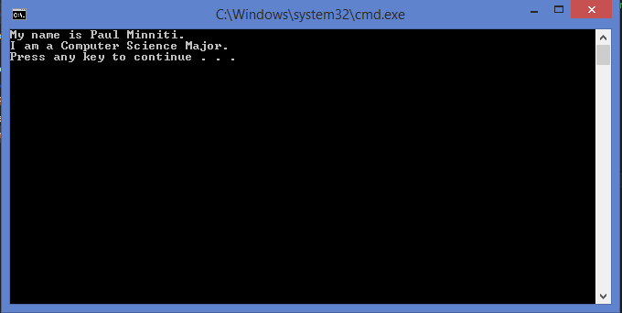

Exercise 2:

Source Code

//Create a new C++ Project called MilesPerHour.Write a program
//that will input miles traveled and hours spent in travel.The
//program will determine the miles per hour.

//Paul Minniti

#include <iostream>
using namespace std;

int main()
{
double miles, mph, hours;

cout << "Please input the number of miles traveled:" << endl;
cin >> miles;

cout << "Please input the number of hours spent traveling:" << endl;
cin >> hours;

mph = miles / hours;

cout << "The average miles per hour is " << mph << endl;

return 0;

}

Sample Output

